**We2-Android Application**

R.Vinston Raja ,S.Ramya , S.Santhiya ,V.Vasantha

panimalar institute of technology

mail id: [ramya9600434700@gmail.com](mailto:ramya9600434700@gmail.com), [sanjothi99@gmail.com](mailto:sanjothi99@gmail.com) , [vasantha190600@gmail.com](mailto:vasantha190600@gmail.com),

winstonroja@gmail.com

**1.Abstract:**

We2 is an android based application that is used to satisfy farmers’ need both in getting machine needed for farming as well as the seeds and pesticides that they need. This is developed to help farmers by providing relevant information to them quickly as possible. This app looks dynamic and interactive to take in the feedback input from the end users and can guide people. This makes to feel that each and every one can do farming. The farmers are provided with good platform to rent or buy things. By this app, farmers are provided with a direct contact with other farmer who is in need for any farming machinery with the farmers who wants to rent their machinery. This application uses a part of idea from the existing application such as what Sapp and Ola to make it quite user friendly among people.

**Keywords:** technical expert, end user, chats.

**2.Overview of We2 application:**

The main aim of this we2 application is that it satisfies farmers’ need both in getting machine needed for farming as well as the seeds and pesticides that they need.

We2 is an android app developed to help farmers by providing relevant information to them quickly as possible.

The farmers are provided with good platform to rent or buy things.

By this app farmers are provided with a direct contact with other farmer who is in need for any farming machineries with the farmers who wants to rent their machineries.

In addition to the dealers information they even get information about the weather report also.

**3.Description:**

This application acts as an interface between farmers who wants to rent their tractor or another machines related to farming to the farmer who needs it.

The unique feature in this app is that it can give information about the nearby users of tractors etc.

Indian government is taking lots of effort to empower farmer in the best manner.

For suppose take an instance, if the farmer doesn’t have any of the machineries to do farming but the farmer has a plot for land and the interest in cultivation and agriculture .Here is the place where our app stands where this app helps the farmer in getting those machineries for rent for certain period of time.

We2 app provides service to the farmer .i.e. customers can search the product or their requirements within their own area.

**4.Purpose:**

This app makes to feel that each and every one can do farming .

This application is use to enhance farmer income, raise in productivity and revenue by using this technology, because agriculture has been one of the important sector in many countries for connecting rural areas to other countries.

We2 can satisfy farmers one of the important problems faced by them such as

* Cannot afford to buy a tractor.
* Water pumps etc.

**5.Critical :**

This app can be based on Java script API , html5 and google maps.

This app can be built using android studio app for android users and apple’s objective c or swift language for iOS users.

First of all we must design an algorithm that automatically detect the location and provide response for the nearest tractor user.

We can use different technology for different platform.

This app is a best platform to the farmers to have profit.

The farmers using our application to first register with our application and login to the system and access the application.

|  |  |  |
| --- | --- | --- |
| Attributes | Data types | Description |
| Name | String | Name of the user |
| User id | Alphanumeric | Id of the user which is a primary key ,that is not null |
| Password | Alphanumeric | Password should be in combination of 1 to 8 characters |
| Confirm password | Alphanumeric | Password should be in combination of 1 to 8 characters |

We made a similar application which is related to farming

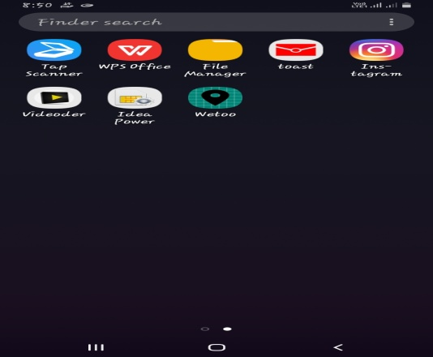

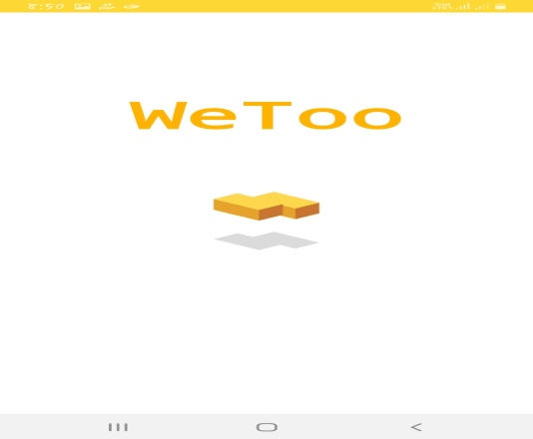

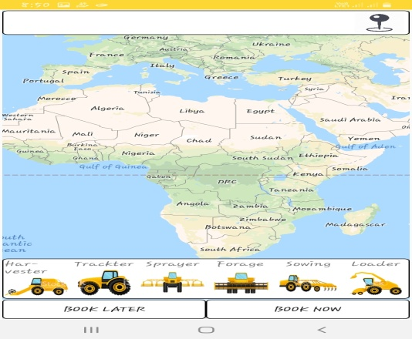

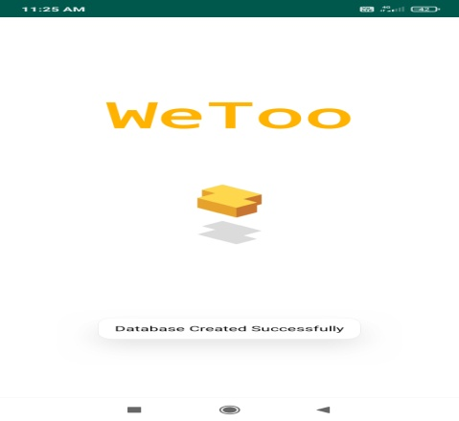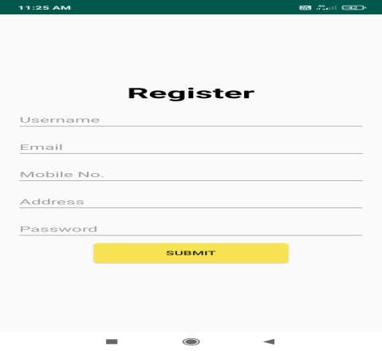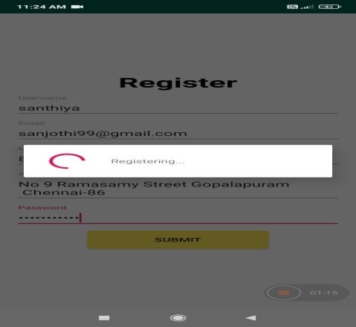

**Database frame:**

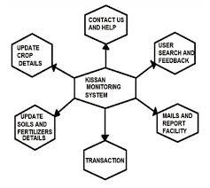

**Data flow diagram:**

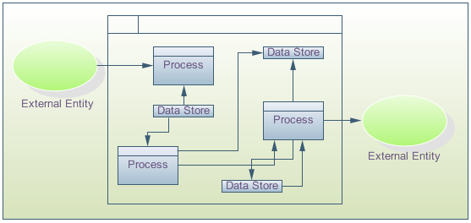

**Future work:**

We2 is a mobile app developed to help farmers by providing relevant information to them quickly. With click of a button, they can get the information on weather of current day , dealers. India have been added to empower farmers in the best possible manner. We2 Android Application Provides (Administrator) features like fertilizers update, Contact us, Help information, also the user (customer) search available.

**Algorithm :**

First of all this we2 application is a cloud based chat service tat means it needs some centralised server to provide all the services. There are three essential parts. They are

* sender
* receiver
* server

The message that is sent to the server it stores it and sends it to the receiver .But it is not as simple as we say .There are lots of issues in it.

The server holds the message for the receiver until it comes online and says “i am online ,give me my messages” and the server sends all the holding messages with time stamps.

Most essential task of the server is to hold all the unsent messages for billions of different users with sender’s id .so the server needs to have a unique key for each users to store all the messages and other essential informations .This is how messages are stored for each user when they are offline.

Our first try was simple and stupid...

1.Make a request and save coordinates.

2.Make another request and animate the tractor.

As we guessed there was several problems with it. we cant animate tractors properly as it moves through field ,forest,lakes and quarters

As the solution for this problem ,we used Open Street Map Routing Machine(OSRM)for building routes and one algorithm improved .

1. We make a request for tractors.
2. Save coordinate.
3. Send saved coordinates to the back end.
4. Build route via OSRM.
5. Return it to client app and animate tractor.

We decided to go for second iteration, because several things needed for improving the algorithm...

First thing was a trip cost calculator .All the calculators were on the tractor owner side. On the other hand its a farmer app ,so we need to duplicate data and save it on the server side.

Moreover, we have lots of problem with GPS module on the owner side .GPS problems are associated with the owner side.

Mainly we had a one major problem to solve .i.e. how to save the mobile data that is present?

As you see we watched for several protocols

1. HTTP
2. TCP
3. UDP
4. WEB SOCKETS

and for us the ideal option was UDP, because...

* we send only datagram.
* We don't need any guarantees.
* minimalism.
* saves mobile data.
* we have only 20 bytes overhead.
* this is not blocked in our country.

**Reference**

[1] Vishal Sharma, Dr.Sunil giri and Siddhartha Shankar Rai, “supply chain management of Rice in India: a Rice processing company perspectives”,international journal of managing value and supply chains (IJMSC) vol.4,no.1,March2013.

[2] Greg linden, Brent smith,and Jeremy York,”amazon. Femre commendations tem-to-item collaborative filtering”published by the IEEE computer society January February 2013.

[3] Li Ma, Li GU and JinWang,” and development of mobile application for android platform”,International journals of multimedia and ubiquitous engineering vol.9 no.4 2014,pp187-198.

[4] Maria Joao and fernandes Abreu, New shopping trends: Internet,second-hand trade and OLX”,Dissertation submitted in partial fulfillment of requirements for the.

[5] Singhal M. Verma, K.; Shukla A.”KrishiVille Android based solution for Indian agriculture,” Advanced Networks and Telecommunication Systems (ANTS), 2011 IEEE 5th International Conference on, vol., no., pp.1,5, 18-21 Dec. 2011 doi: 10.1109/ANTS.2011.6163685.

[6] Androiddevelopershttp://developer.android.com/intl/zhCN/guide/index.html.

[7] Jin Yan, Yao Shanglang. Getting started and actual development of Google Android (in Chinese) [M]. Posts and Telecom Press, 2009.

[8] Maurya, B.; Beg, M.R.; Mukherjee S.”Expertsystem design and architecture for farming sector,” Information and Communication Technologies (ICT), 2013